Blanket Parental Permission and Release Form – Private Vehicle

Native Education and Aboriginal Services
650 Kawkawa Lake Road
Hope, BC V0X 1L4
Phone: 604-869-2842
Fax: 604-869-7400
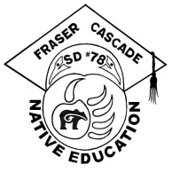
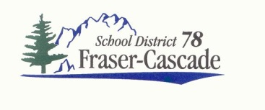

PARENTAL PERMISSION AND RELEASE FORM – PRIVATE VEHICLE

Excluding special Field Trip events, it is a possibility that a student may need to be driven somewhere (work experience, doctor, hospital, etc.) during school hours. In order for me to accommodate this, if necessary throughout the school year I must have written permission on file from each Aboriginal student’s parent/guardian.

I would appreciate it if you would complete the following Consent Form and return it to me to have on file in case I need to transport your child.

I give my permission and consent for _________________________________________
(Name of Student)

to ride in the private automobile belonging to _______________________________________,
(Name of First Nations Support Worker)

and driven by him/her, provided that s/he has provided a current Criminal Record Check, Driver’s

Abstract, and Application for Use of Private Vehicle/Volunteer Form to the school/district.

________________________________________ _______________________________
(Signature of Parent/Guardian) (Date)

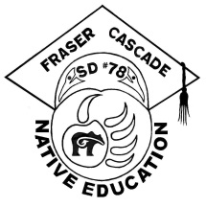
Native Education, S.D. #78
650 Kawkawa Lake Road
Hope, B.C. V0X 1L4
Phone: (604) 869-2842
Fax: (604) 869-7400
Email: miranda.cowan@sd78.bc.ca

Aboriginal Education Consent Form

I, the undersigned, am the parent or lawful guardian of __________________________________________ who is a student at ______________________________ school and I confirm that he/she is First Nations or has Aboriginal ancestry and is entitled to all First Nation programs and services available at the school.

Please check off/complete the following and return this form to your child’s school:

My child is:
Métis Status, living off-reserve Non-status living on-reserve
Inuit Status, living on-reserve Does not have Aboriginal ancestry
Non-status, living off-reserve

If your child is status, please let us know his/her status number _______________________________

Band of Residence (if living on reserve only):
Boothroyd Cheam Sq’éwlets Sq’ewá:lxw
Boston Bar Sts’ailes Seabird Island Spuzzum
Chawathil Peters Shxw’owhamel Union Bar
Yale

I give permission to the First Nations Support Worker to:
give my child academic support in the classroom
provide emotional support, when necessary
work with my child to increase awareness of cultural diversity.

I give permission to the First Nations Support Worker to access student records, when necessary, in order to assist in the carrying out of his/her duties.

- I give permission for SD78 Child Care Counselors to meet quarterly with my child/children.

I give permission for SD78 (Fraser-Cascade) Native Education and Aboriginal Services to use any photographs of my child taken at school functions during the school year and to use my child’s name in association with the photographs for the Native Ed Year End Report and to be posted at the school during the school year.

(For students living on reserve only) I give permission for the school to share information about my child’s progress with the Education Manager of our Band.

Name of Parent or Lawful Guardian (please print): _______________________________________________

Signature of Parent or Lawful Guardian: _______________________________________________________

Address of Parent or Lawful Guardian: ________________________________________________________

Date of Signing: ______________________ Email Address: ____________________________________

Phone: Home _________________ Cell ________________ Work ________________ (Text only )

Aboriginal Education Consent Form, revised July 12, 2018

